11.77: a) The angle at which the bale would slip is that for which The angle at which the bale would tip is that for which the center of gravity is over the lower contact point, or arctan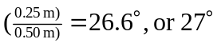to two figures. The bale tips before it slips. b) The angle for tipping is unchanged, but the angle for slipping is arctan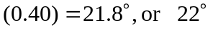to two figures. The bale now slips before it tips.

